Assignment 1: Java

Task 1:
UMLs
DriversLicense
-firstName: String
-lastName: String
-eyeColor: String
-sex: char
-height: double
-dateOfBirth: String
-street:String
-city: String
-province: String
-postalCode: String
-licenceNumber: String
-licenceClass: String
-restrictions: String
-issueDate: String
-expiryDate: String
+DriversLicense()
+DriversLicence(fname: String, lname: String, eyeColor: String, sex: char, height:double, dateOfBirth: String, street: String, city: String, province: String, postalCode: String, licenceNumber: String, licenceClass: String, restrictions: String, issueDate: String, expiryDate: String)
+DriversLicence(fname: String, lname: String, eyeColor: String, sex: char, height:double, dateOfBirth: String, street: String, city: String, province: String, postalCode: String, licenceNumber: String, issueDate: String)
+computeDaysToExpiry(): int
+computeDriverAge(): int
+computeDaysSinceIssue(): int
+computeYearsSinceIssue(): int
+computeHeightInInches(): double
+printLicenseReport(): String

Tester
+main(args: String []): void

Task 2:
//screenshot of program output
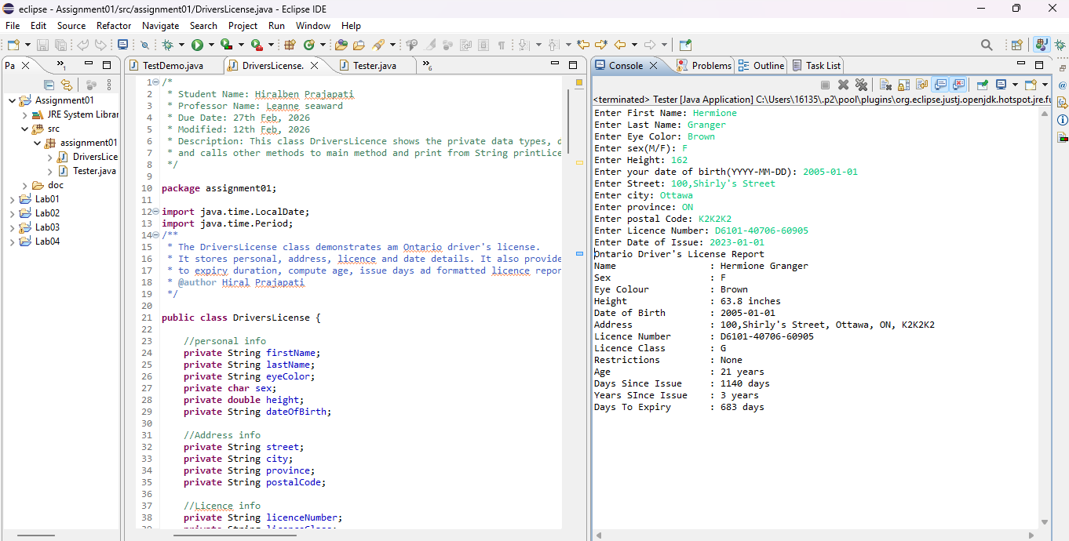
Task 3:
//Screenshot of Junit test
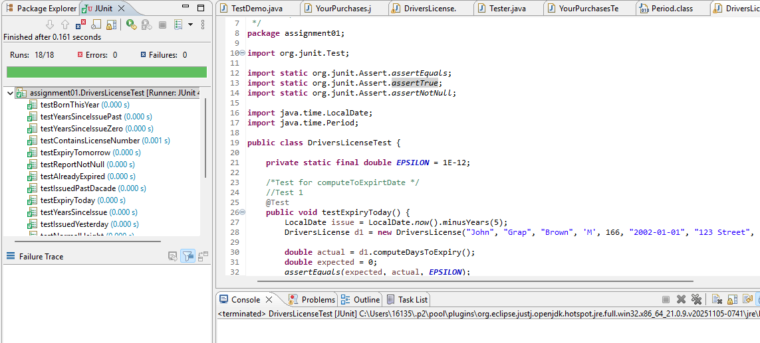

Task 4:
//Screenshot of JavaDoc
- Tester.java
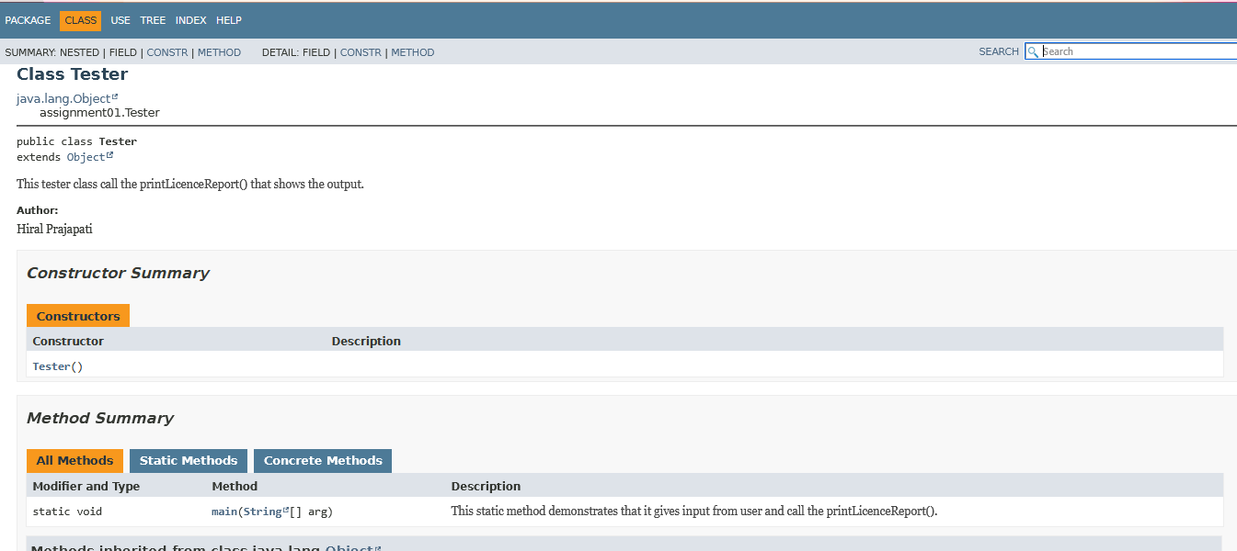
- DriversLicence.java
